**ABSTRACT**

DINOVA, VINCENT. Automated Variable Selection of Gamma-Ray Spectra by Utilization of LASSO and Elastic Net Techniques for Use in Nuclear Security Applications. (Under the direction of Dr. Robin P. Gardner.)

Shortly after the tragedies of 9/11/2001, the National Academies of Science commissioned a study on the dangers of long-lived radioisotope sources.  The study concluded that there exist several commonly used sources that could potentially be used as a dirty bomb or terror weapon.  The Consortium for Nonproliferation Enabling Capabilities (CNEC) was funded in 2014 to research innovative ways to address nuclear security problems including finding suitable replacements for dangerous radiological sources.  Devices used in the oil well logging industry were identified as a major point of interest as they utilize high activity Cs-137 and AmBe sources for density, porosity, and elemental composition measurements.  A testing facility and benchmarking tool were designed and built at Kansas State University to test the viability of replacing traditional active sources with a D-T Pulsed Neutron Generator.  It has been found that by exploiting the pulsing time responses with a digitizer, prompt and delayed responses can be extracted.  Supervised machine learning techniques, LASSO and Elastic Net, are applied to the prompt and delayed responses, offering on line analysis in a changing environment with improved capabilities over traditional linear least squares methods.

Nuclear Engineering PhD Preliminary Exam

Automated Variable Selection of Gamma-Ray Spectra by Utilization of LASSO and Elastic Net Techniques for Use in Nuclear Security Applications

North Carolina State University

Raleigh, North Carolina

February 21, 2019

Vincent A. DiNova

Presented to the Committee:

|  |  |  |  |  |  |
| --- | --- | --- | --- | --- | --- |
| |  | | --- | |  | | |  | | --- | |  | | |  | | --- | |  | |
| Dr. Dimitry Anistrotov | Dr. Ge Yang | Dr. Steven Shannon |

|  |  |  |  |
| --- | --- | --- | --- |
|  | |  | | --- | |  | |  |

Dr. Ralph Smith

With Committee chair:

|  |  |  |  |
| --- | --- | --- | --- |
|  | |  | | --- | |  | |  |

Dr. Robin P. Gardner

**CHAPTER 1**

**Introduction**

1.1 Background

Shortly after the tragedies of 9/11/2001, the National Academies of Science commissioned a study on the dangers of long-lived radioisotope sources.  The study concluded that there exist several commonly used sources that could potentially be used as a dirty bomb or terror weapon.  The Consortium for Nonproliferation Enabling Capabilities (CNEC) was funded in 2014 to research innovative ways to address nuclear security problems including finding suitable replacements for dangerous radiological sources.  Devices used in the oil well logging industry were identified as a major point of interest as they utilize high activity Cs-137 and AmBe sources for density, porosity, and elemental composition measurements.  A testing facility and benchmarking tool were designed and built at Kansas State University to test the viability of replacing traditional active sources with a D-T Pulsed Neutron Generator.  It has been found that by exploiting the pulsing time responses with a digitizer, prompt and delayed responses can be extracted.  Supervised machine learning techniques, LASSO and Elastic Net, are applied to the prompt and delayed responses, offering on line analysis in a changing environment with improved capabilities over traditional linear least squares methods.

Table 1: NAS findings

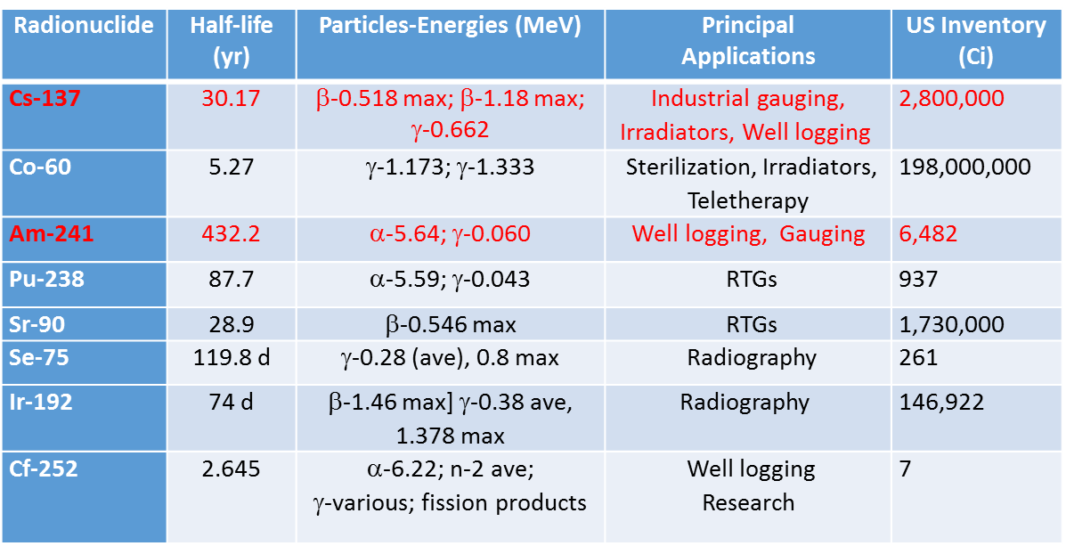

1.2 Overview

The benchmarking tool and design facility were designed and constructed at Kansas State University. The tool consists of near and far gamma and neutron detectors separated from a D-T pulsed neutron generator source by a 2” lead divider.

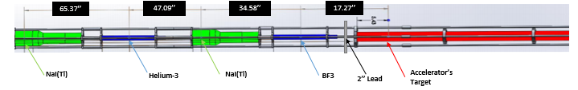

Figure 1: KSU benchmarking tool

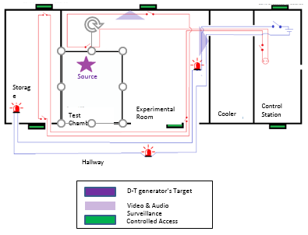

Figure 2: KSU design facility

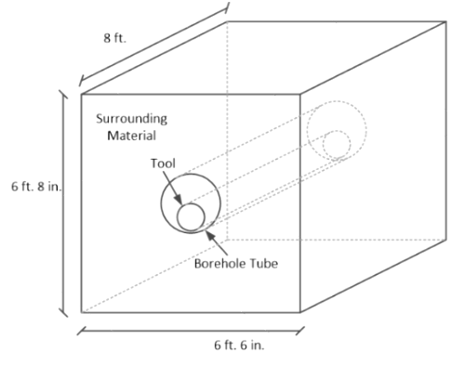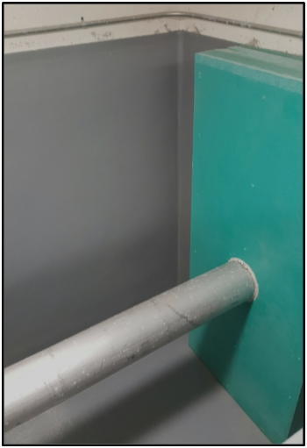

Figure 3: Test chamber

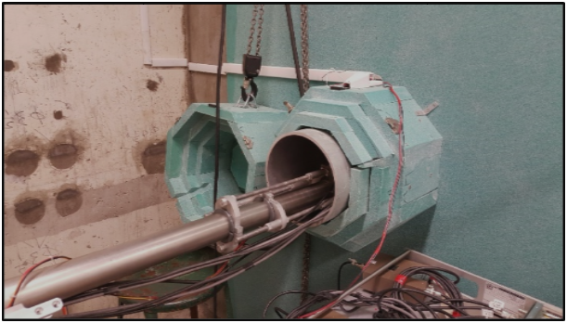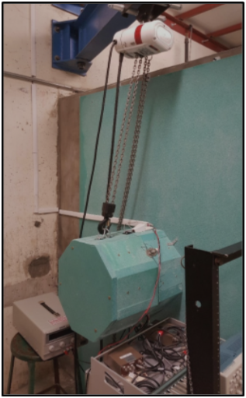

Figure 4: a. Open borehole tube and b. capped borehole tube

**2. Introduction to PGNAA**

Prompt gamma-ray neutron activation analysis is a nondestructive, near real time technique used for bulk material identifications. PGNAA relies on neutron inelastic scatter and capture reactions to produce characteristic gamma-rays used to identify minute amounts of elements in a bulk sample. Due to low cross sections for these reactions, background sources from natural radiation, activation of the NaI detector, and gamma-rays from the decay of the neutron source a low signal to noise ratio (SNR) is common. In order to increase the SNR, a coincidence counting technique is applied.

**2.1. Neutron Inelastic Scatter**

Neutron inelastic scatter involves an incoming neutron colliding with a target nucleus and exiting with less energy and at a different angle than it entered. The energy deposited on the target nucleus causes it to reach an excited state and rapidly releases a gamma-ray to return to its normal energy state represented in equation 1 as follows:

|  |  |  |
| --- | --- | --- |
|  |  | (1) |

Note: Neutron inelastic scatter does not produce gamma-rays in coincidence and is not necessary to the analysis for coincidence counting. CEARCPG does include the capability of producing a single PGNAA spectra and was included for this purpose.

**2.2 Neutron Capture**

Neutron capture, also denoted as (n, γ), can occur over a wide range of energies and has the highest probability at thermal energies. The (n, γ) reaction begins when a neutron interacts with a target nucleus and is absorbed. The newly formed nucleus is placed in an excited state, and in order to form a new ground state, at least one γ photon is emitted as shown in eq. 2 below.

|  |  |  |
| --- | --- | --- |
|  |  | (2) |

Each nucleus (apart from Helium-4) gives off a distinct signature of intensities and energies, allowing for the identification of the sample from the γ photon emissions.